**October Monthly Report**

Zihan Qiao (Weibo)

**The workflow of Weibo in October**

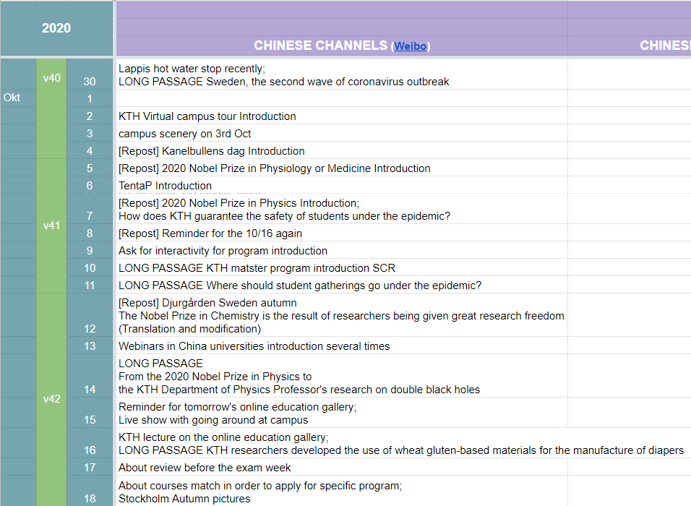

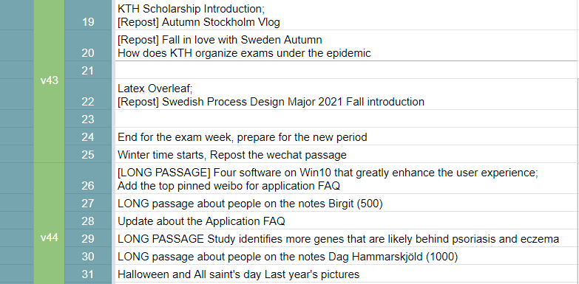

Figure 1 Content Sheet for September

The number of long passages: 8;

Missed days: 3;

**Statistics**

Until 2020/11/1, there are 21762 fans. There are 3916 new followers compared with 2020/9/2.

In this month, I published 8 long passages and many short weibo.

**Shining point:**

1. The application FAQ continuous updating and pinned to the top;
2. Master program introduction including SCR program and CS program (published on 2020/11/1)
3. Finish the series about Swedish krone notes. The 500 and 1000 notes. Birgit and Dag
4. Many passages about Nobel Prize and related KTH research
5. KTH scholarship
6. Focus on the demands of Chinese students and their parents. Useful information about application.

**Weaknesses:**

1. Little pictures. Less outside travel because of coronavirus.
2. A little lack of working passion. Need to WRITE a lot of NEW things!

**November Plan:**

Swedish songs topic Already discussed with the boss of Wechat group

Personal introduction of the boss behind the weibo group and wechat group and QQ group, which I get inspired from Ivan, the boss of Instagram group

Focus on the application FAQ updating. Transfer more questions in QQ group to pinned weibo passage

More information about the covid situation

Observe that if it will influence the traditional festivals in November

More share about personal life, especially on cooking. After all, long night is coming.

**Personal feelings**

The first week of period 2 has passed. The workflow I am 100% used to. Hope that I can perform better. The responsible Chinese teachers gave me some positive feedback. You can also send me some emails and tell what aspects that the KTH admission what to focus on, especially for Chinese students. This year, most Chinese students cannot go to America to pursue higher degree. They will think about European universities a lot, which can also be seen in the number of QQ group.

Writing time: 2020/11/1 21:20-21:49